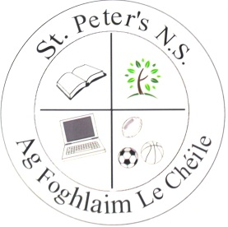

St. Peter’s National School
Church of Ireland,

Maynooth Road, Dunboyne, Co. Meath

Telephone: 01-8026741
Email Addr: stpetersnsdunboyne@gmail.com
Web site: stpetersnsdunboyne.ie

Proposed Holiday List 2019/20
(Dates subject to change)

School re-opens: Thursday 29th August

October Mid-Term Break: Monday 28th October to
Friday 1st November (inclusive)

Christmas Holiday: Friday 20th December
(final day of term)
School re-opens Monday 6th January

February Mid-Term Break: Monday 17th to
Friday 21st February (inclusive)

St. Patrick’s Day Holidays: Monday 16th & Tuesday 17th March

Easter Holiday: Friday 3rd April
(final day of term)
School re-opens Monday 20th April

May Bank Holiday: Monday 4th
Bank Holiday

June Bank Holiday: Monday 1st June
Bank Holiday

Summer Holiday: Friday 26th June
School closes for summer break

